Ex.no:9 | MINI PROJECT – AMAZON SALES  DATA ANALYTICS
Date: | MINI PROJECT – AMAZON SALES  DATA ANALYTICS

Domain and Problem Statement:
Domain: E-Commerce Analytics & Sales Performance
Problem Statement: E-commerce businesses generate large volumes of sales and customer transaction data, making it difficult to identify sales trends, product performance, customer preferences, and revenue patterns efficiently. This project addresses these challenges by transforming raw Amazon sales records into structured business intelligence using Power BI and Tableau to analyze sales performance, product categories, customer regions, payment methods, discounts, ratings, and revenue trends for better business decision-making.

Dataset Description:
Dataset Name: Amazon Sales Dataset
Granularity: Each row represents a single Amazon sales order/transaction.
Timeframe Covered: 2022 to 2023.
Key Entities & Attributes:
- Order & Product Details:
order_id, order_date, product_id, product_category
- Pricing & Sales:
price, discount_percent, discounted_price, quantity_sold, total_revenue
- Customer & Payment Details:
customer_region, payment_method
- Customer Feedback:
rating, review_count
- Time-Based Attributes:
Year, Month
Dataset Size: 50,000 rows and 15 columns.

Data Source:
Primary Source: Kaggle Open Datasets (Amazon Sales Dataset).
Storage Infrastructure:
Cleaned sales records hosted within a local SQL Server database instance (SalesDB) and connected to Power BI and Tableau for analysis and visualization.
Program:
1. Python – Data Cleaning & Transformation
import pandas as pd
from sqlalchemy import create_engine, text
# Load dataset
df=pd.read_csv("C:/Users/ramya/Downloads/amazon_sales_dataset.csv")
print("Dataset loaded successfully!")
print("Shape:", df.shape)
print("Columns:", df.columns.tolist())
# Check dataset information
df.info()
# Check missing values
print("\nMissing Values:")
print(df.isnull().sum())
# Check duplicate records
print("\nDuplicate Rows:", df.duplicated().sum())
# Display first 5 records
df.head()
# Convert order_date to datetime
df["order_date"] = pd.to_datetime(df["order_date"])
# Check the data type
print(df["order_date"].dtype)
# Display date range
print("Start Date:", df["order_date"].min())
print("End Date:", df["order_date"].max())
# Check minimum values of numeric columns
print("Minimum Values:")
print(df[[
"price",
"discount_percent",
"quantity_sold",
"rating",
"review_count",
"discounted_price",
"total_revenue"
]].min())
# Check maximum values of numeric columns
print("Maximum Values:")
print(df[[
"price",
"discount_percent",
"quantity_sold",
"rating",
"review_count",
"discounted_price",
"total_revenue"
]].max())
# Standardize text columns
text_columns = [
"product_category",
"customer_region",
"payment_method"
]
for col in text_columns:
df[col] = df[col].str.title()
# Check the unique values
for col in text_columns:
print(f"\n{col}:")
print(df[col].unique())
# Create date-based columns
df["Year"] = df["order_date"].dt.year
df["Month"] = df["order_date"].dt.month

# Check the new columns
print(df[["order_date", "Year", "Month"]].head())
print("\nYears:", df["Year"].unique())
print("Months:", df["Month"].unique())
# Calculate expected revenue
df["Calculated_Revenue"] = (
df["discounted_price"] * df["quantity_sold"]
)
# Check difference
df["Revenue_Difference"] = (
df["total_revenue"] - df["Calculated_Revenue"]
)
print("Maximum Revenue Difference:",
df["Revenue_Difference"].abs().max())

print("\nSample comparison:")
print(df[[
"discounted_price",
"quantity_sold",
"total_revenue",
"Calculated_Revenue",
"Revenue_Difference"
]].head())
# Remove temporary columns
df.drop(
columns=["Calculated_Revenue", "Revenue_Difference"],
inplace=True
)
# Check final columns
print("Columns:", df.columns.tolist())
print("Shape:", df.shape)
# Final data quality check
print("Missing Values:")
print(df.isnull().sum())
print("\nDuplicate Rows:", df.duplicated().sum())
print("\nData Types:")
print(df.dtypes)
# Save the cleaned Sales dataset
output_path = "C:/Users/ramya/Downloads/amazon_sales_cleaned.csv"
df.to_csv(output_path, index=False)
print("Cleaned Sales dataset saved successfully!")
print("Rows:", df.shape[0])
print("Columns:", df.shape[1])

2. SQL – Database and Data Loading
SQL Server Management Studio (SSMS):
Database Creation:
CREATE DATABASE SalesDB;
Select the Database:
USE SalesDB;
The cleaned Amazon sales dataset was imported into the SQL Server database as the table:
dbo.amazon_sales_cleaned
SQL Server Data Loading:
The cleaned dataset was loaded into the local SQL Server instance using SQL Server Import and Export Wizard.
Server: localhost
Database: SalesDB
Table: dbo.amazon_sales_cleaned
Data Verification:
The imported table was verified using SQL queries:
USE SalesDB;
SELECT COUNT(*) AS Total_Rows
FROM dbo.amazon_sales_cleaned;
The dataset contains:
Total Rows: 50,000
To inspect the imported records:
SELECT TOP 10 *
FROM dbo.amazon_sales_cleaned;
The SQL Server database was then used as the data source for Power BI and Tableau analysis and dashboard development.
Procedure:
Step 1: Data Preparation & Preprocessing (Python / Pandas)
- Load the Amazon Sales dataset using pd.read_csv().
- Validate the dataset for missing values and duplicate records across all 15 columns.
- Format the order_date column as a datetime field and derive Year and Month attributes for time-based analysis.
- Verify the cleaned dataset contains 50,000 rows, 15 columns, 0 missing values, and 0 duplicate records.
- Import the cleaned sales records into the local SQL Server database SalesDB, using the table dbo.amazon_sales_cleaned.
- Connect the SQL Server database to Power BI and Tableau for visualization and dashboard development.
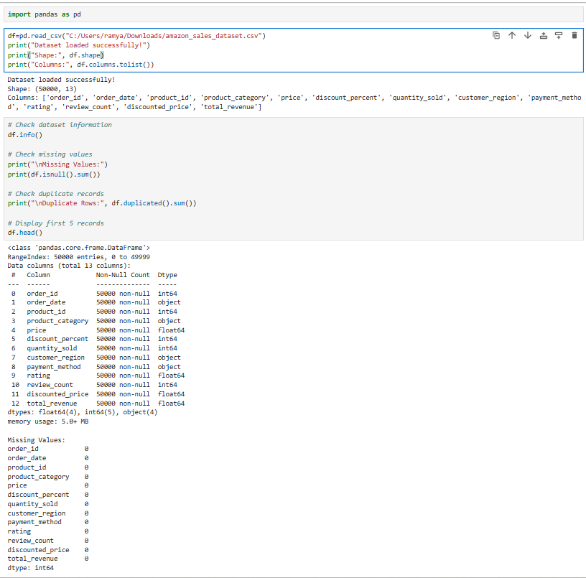
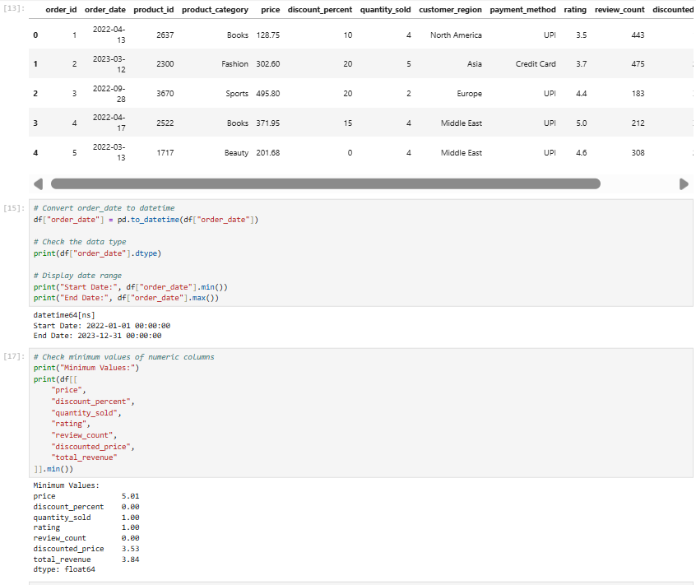
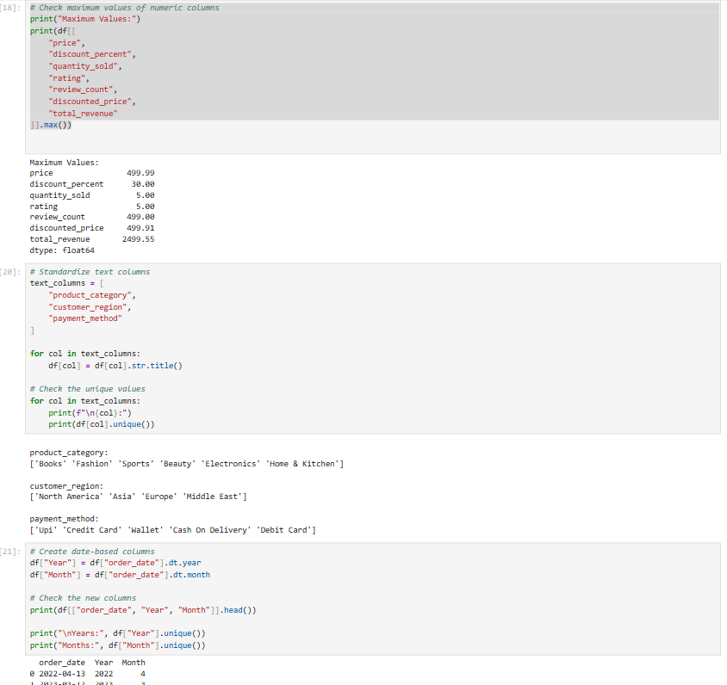
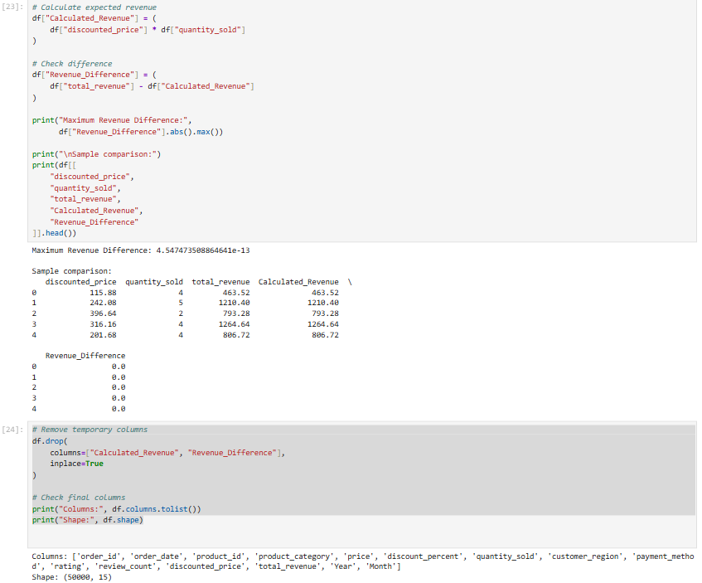
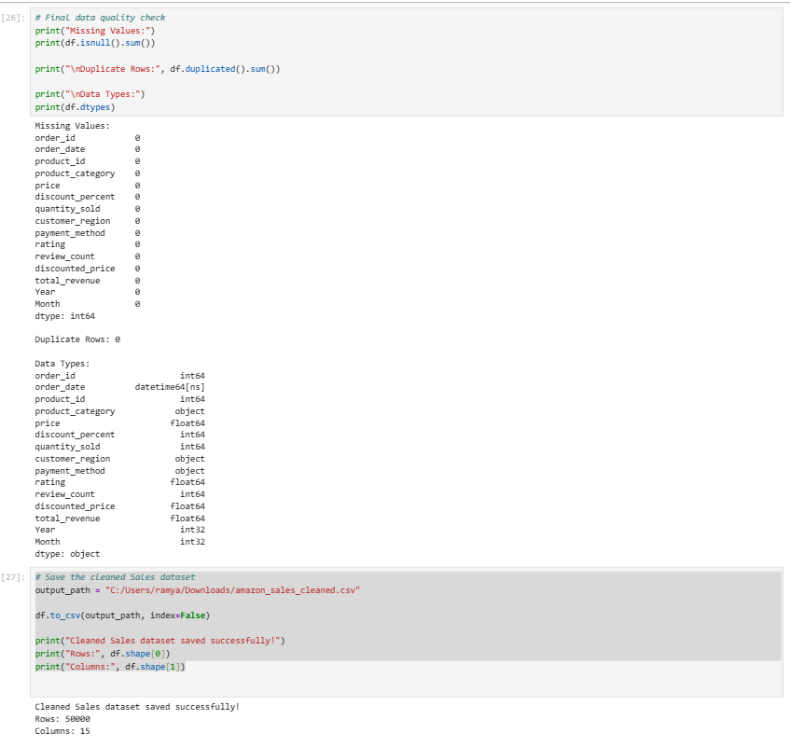
Step 2: Power BI – SQL Server Data Connection
- Open Power BI Desktop → click Get Data → select SQL Server database.
- Enter the Server as localhost and select the database SalesDB.
- Select the table dbo.amazon_sales_cleaned and click Transform Data to open Power Query.
- In Power Query, verify the column names and data types, particularly order_date, price, quantity_sold, discount_percent, rating, total_revenue, Year, and Month.
- Click Close & Apply to load the cleaned sales data into Power BI for dashboard development.
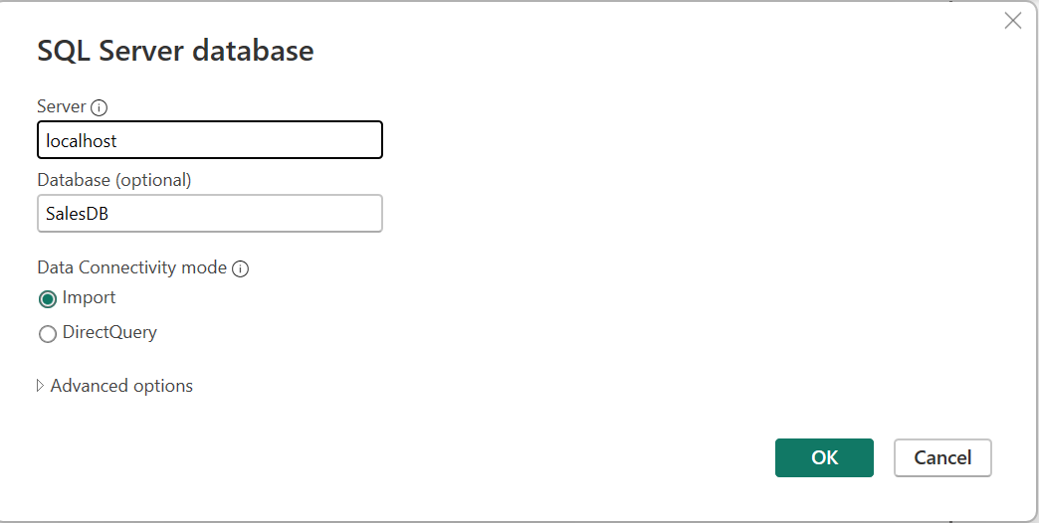

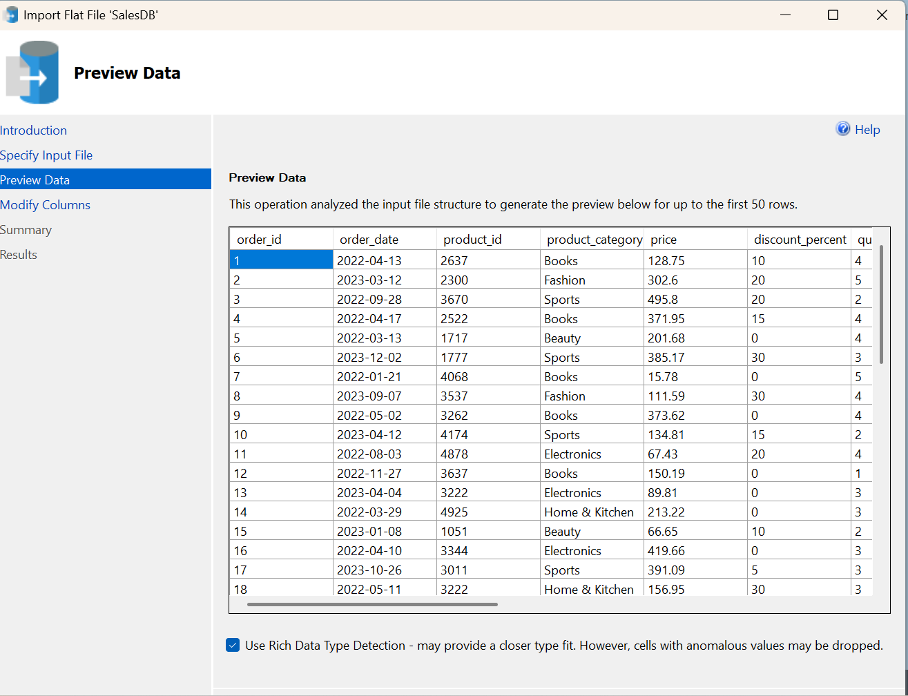

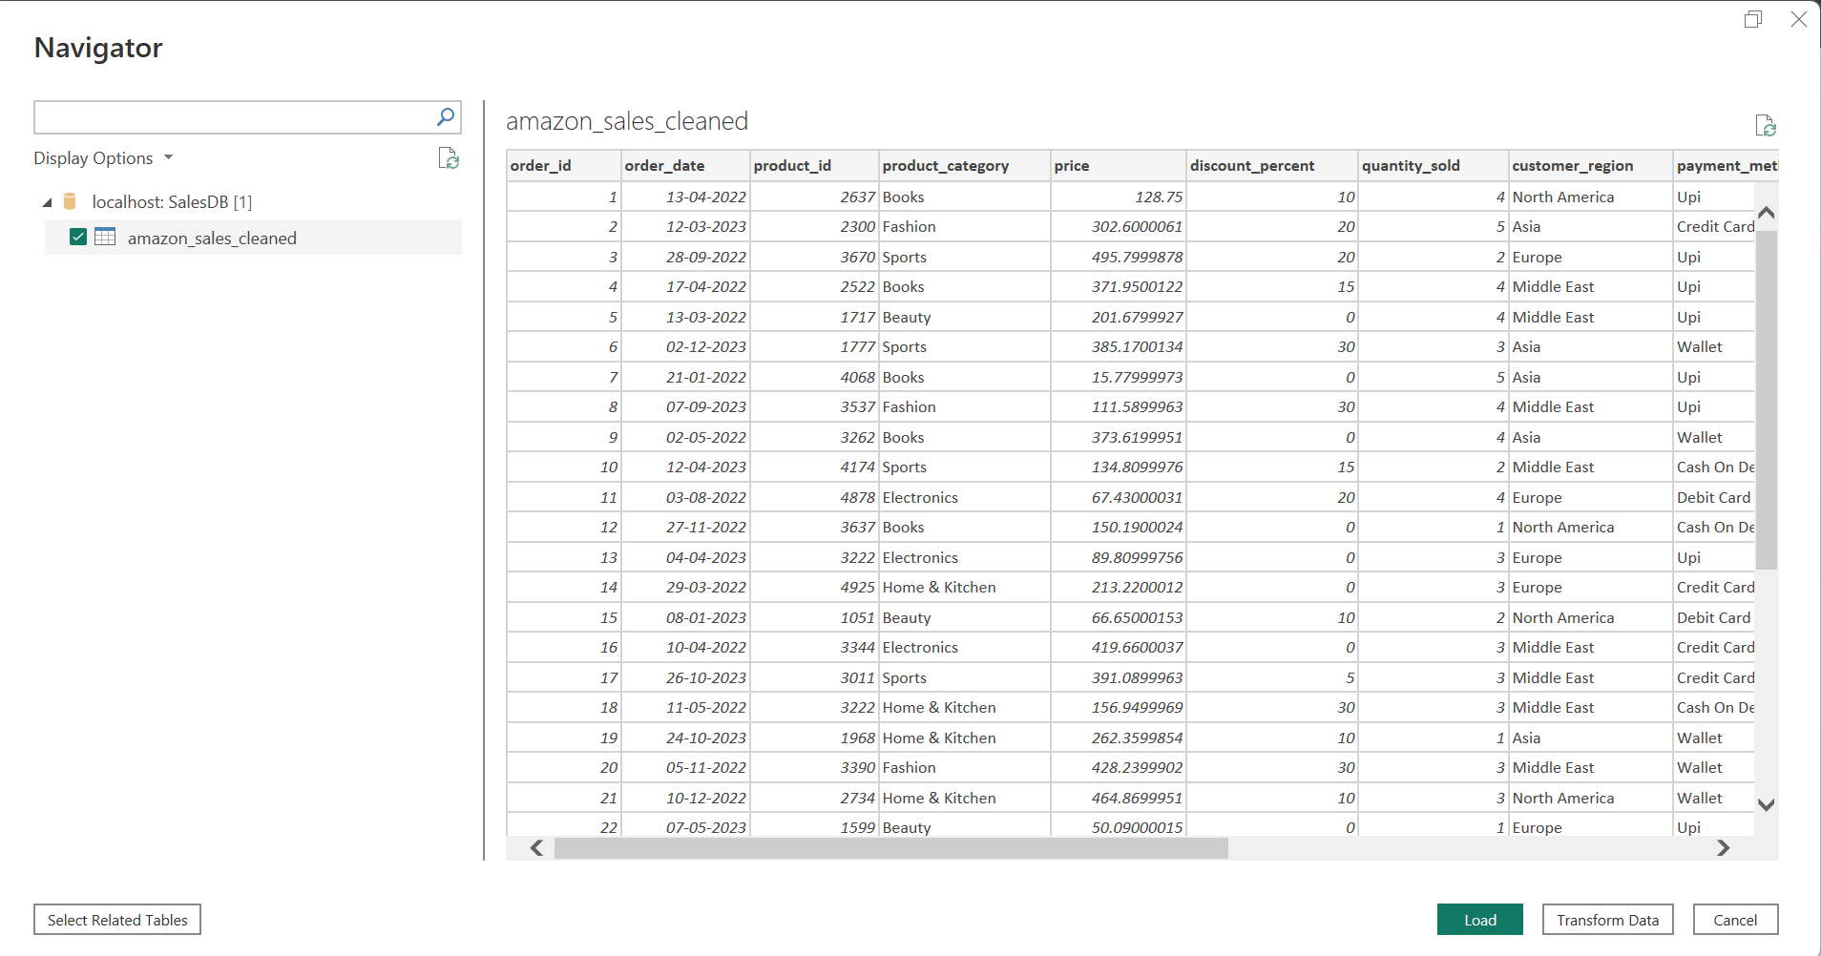

Step 3: Data Modeling and DAX Calculations (Power BI)
1. Data Preparation
The cleaned amazon_sales_cleaned table was imported into Power BI through SQL Server. The data types and field names were verified in Power Query before loading the data into the report.
2. Calculated Columns
Calculated columns were created using DAX to support time-based and sales analysis. The columns were added based on the requirements of the dashboard.

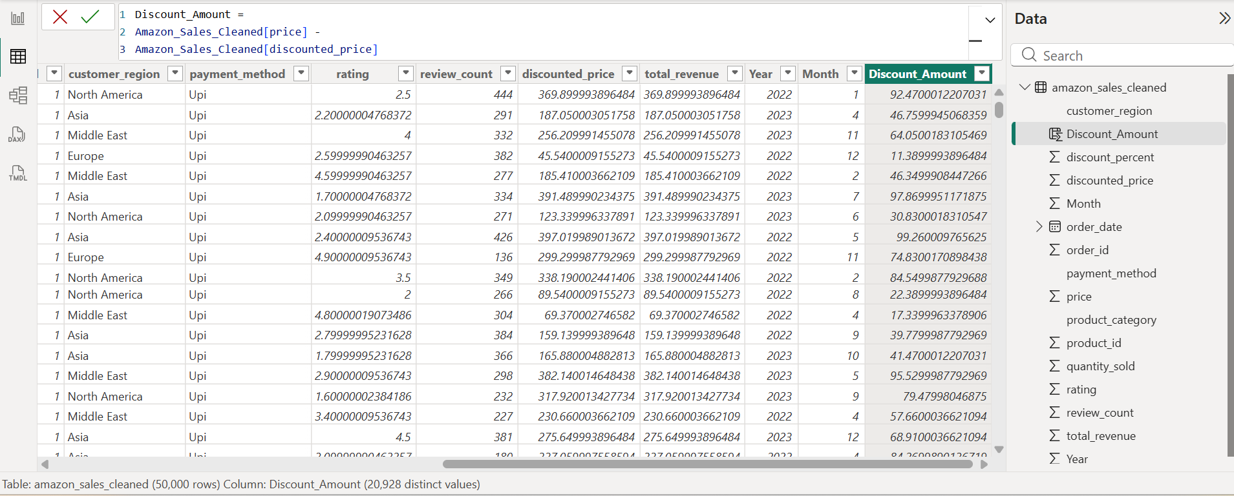

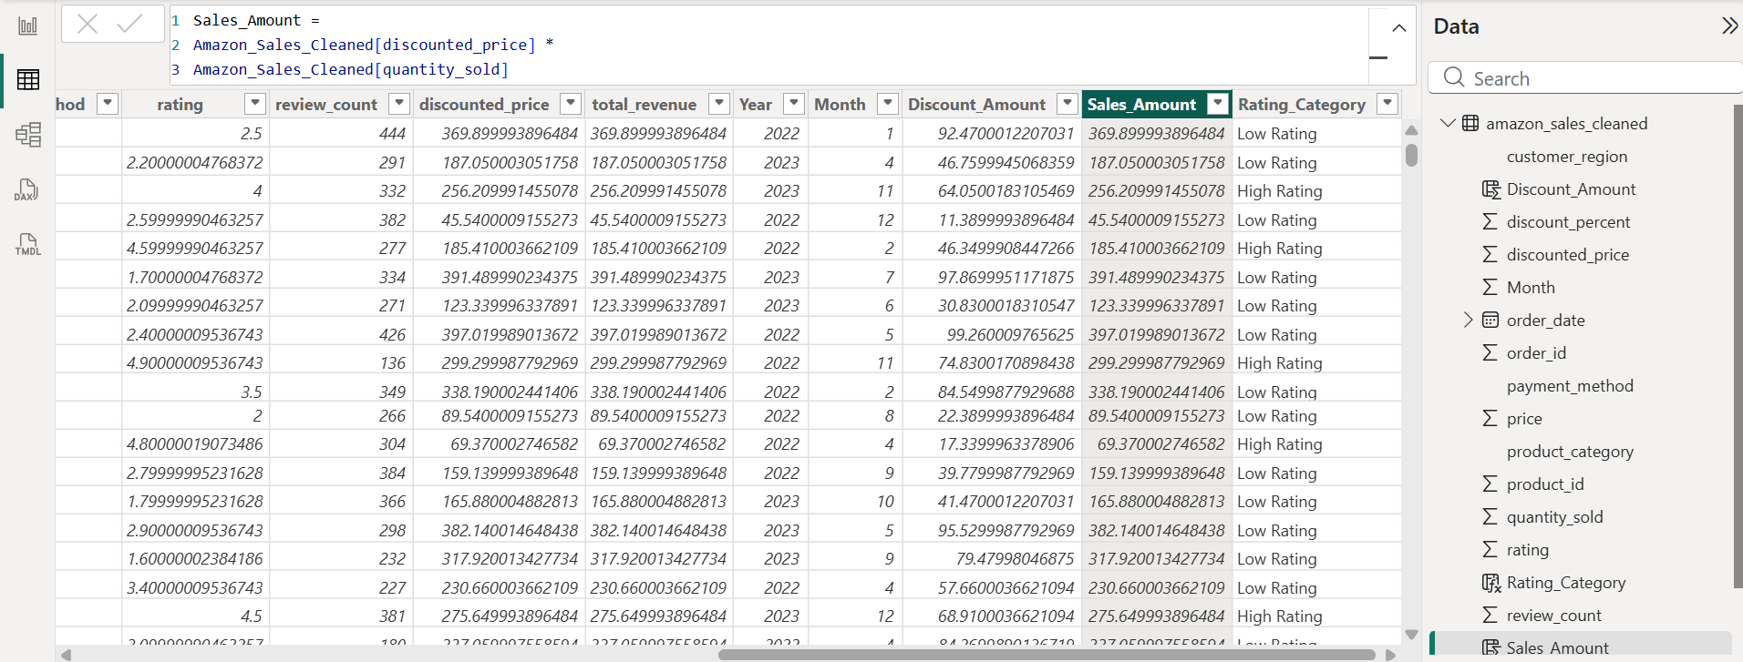

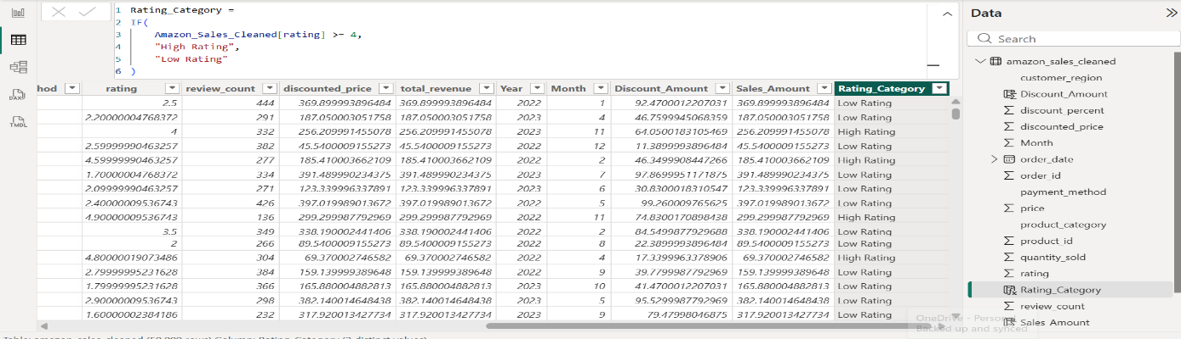
3. DAX Measures
DAX measures were created to calculate important business metrics such as Total Revenue, Total Orders, Total Quantity Sold, Average Rating, and other sales-related KPIs.
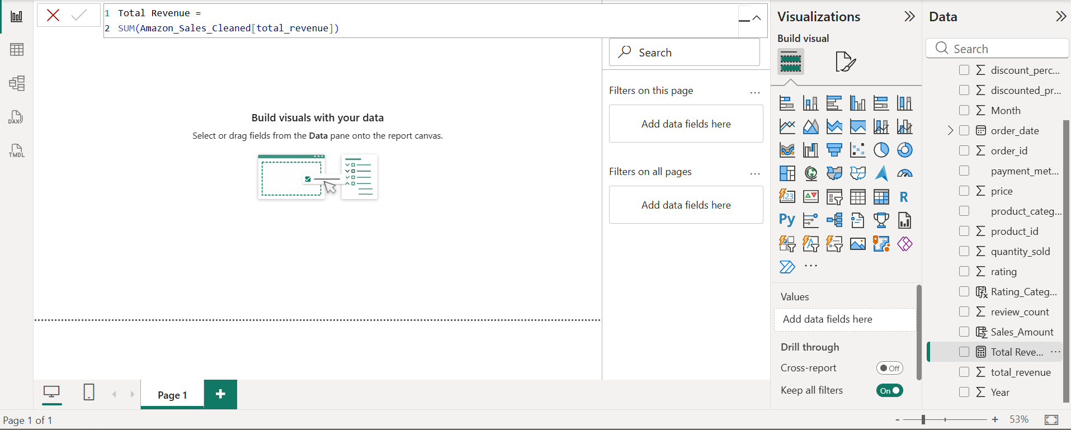
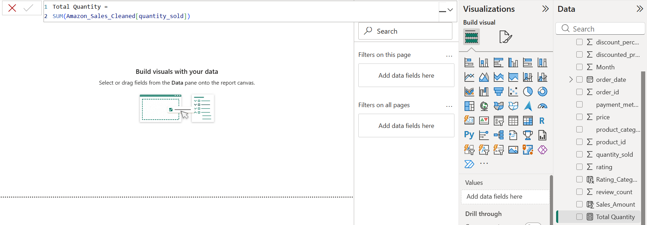

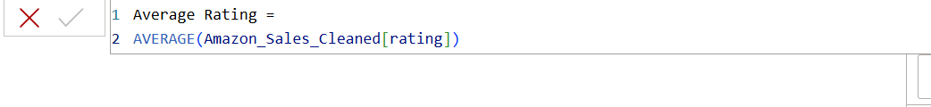

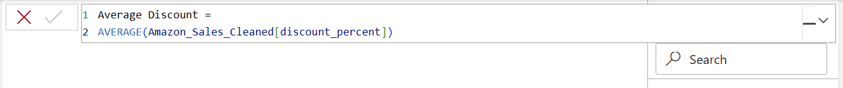
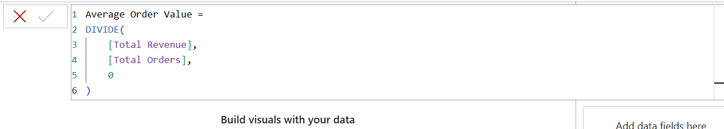
4. Data Model
The cleaned sales table was used as the primary data model for the dashboard. The model was validated to ensure that all fields required for calculations, filters, KPIs, and visualizations were available.
The calculated columns and DAX measures were subsequently used in cards, charts, slicers, and other interactive dashboard components.

Step 4: Power BI Final Executive Dashboard & Drill-Through

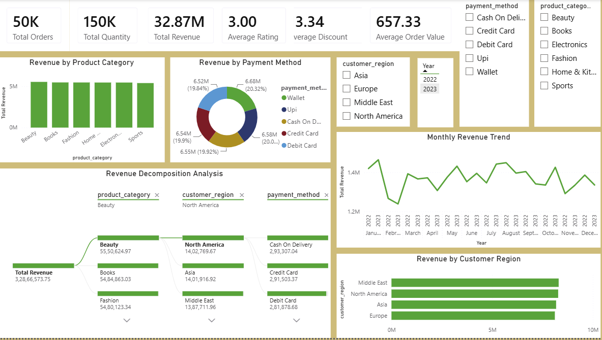

- Executive Canvas:
  - Place Card Visuals across the top: Total Orders, Total Revenue, Total Quantity, Average Rating, Average Discount, Average Order value.

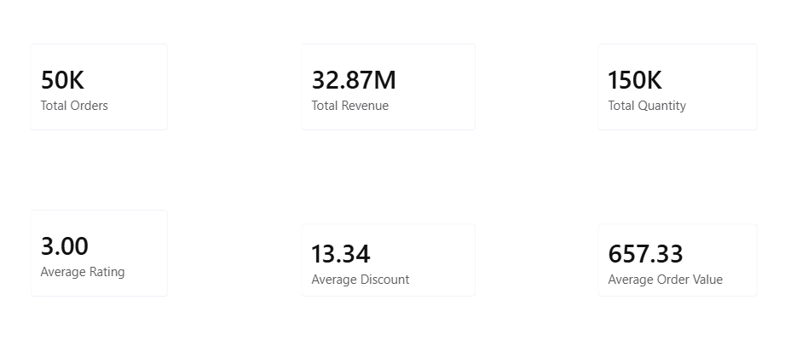

  - Add a Line Chart for Monthly RevenueTrend

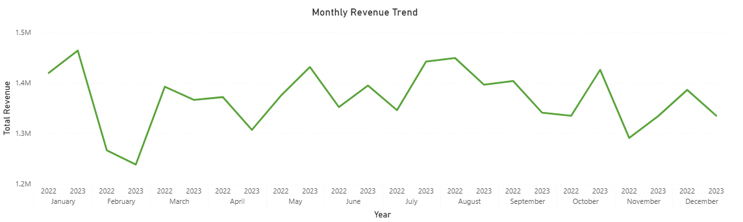

  - Add a Clustered Bar Chart for Revenue by Customer Region

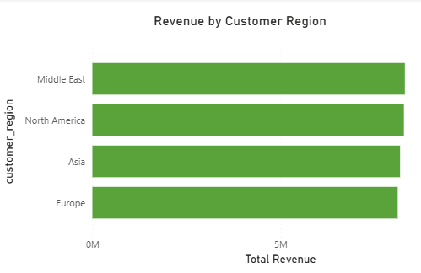

  - Add a Donut Chart for Revenue by Payment Method.

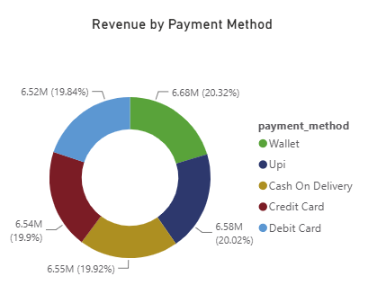
  - Add Slicers for Year, Customer Region, Payment Method, Product Category.

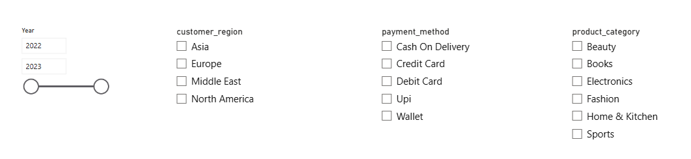
- State Details Drill-Through Page:
- Create a second page named Page 2.
- Use the Monthly Revenue Trend line chart from the main dashboard as the source for drill-through.
- Configure the drill-through using the Month field.
- Add detailed sales visuals to analyze the selected month.
- Add a Table/Matrix showing order_date, product_category, quantity_sold, discounted_price, and total_revenue.
- Add a Bar Chart showing Total Revenue by Product Category.
- Add a Back Button to return to the main dashboard.
- When a month is selected from the Monthly Revenue Trend, the user can drill through to Page 2 and view the detailed sales information for that month.

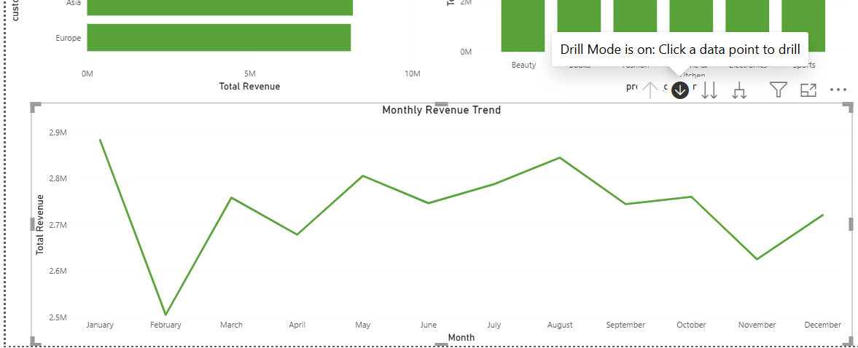

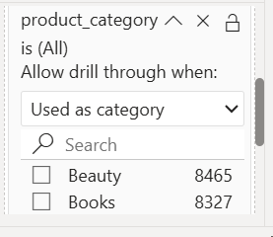
Step 5: Tableau Data Connection & Preparation
- Open Tableau Desktop / Tableau Public.
- Under Connect, select Microsoft Excel.
- Browse and select the cleaned Amazon Sales Excel dataset.
- Load the Excel file into Tableau and verify that all 15 columns are available.
- Check the data types of important fields such as order_date, price, quantity_sold, discount_percent, rating, and total_revenue.
- Use the prepared dataset to create worksheets, filters, calculated fields, and interactive dashboards in Tableau.

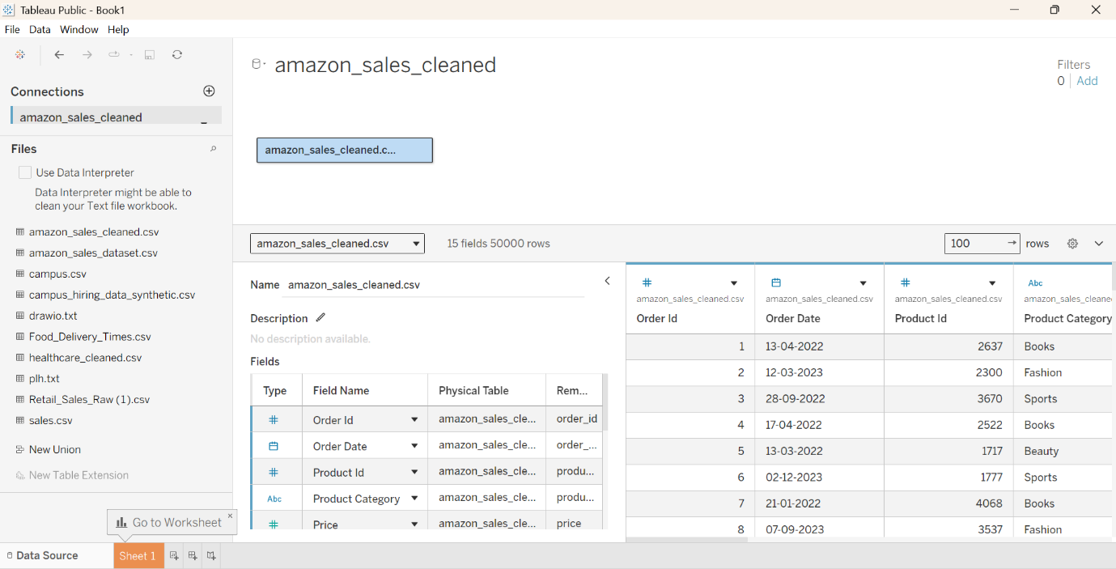
- Rating Category:
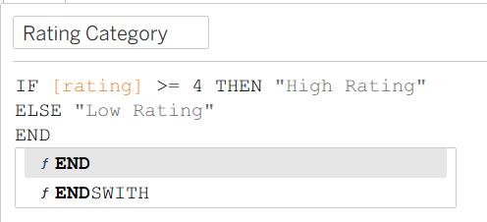
- Sales Amount:
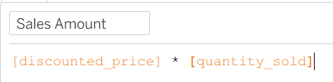

- Revenue Status:
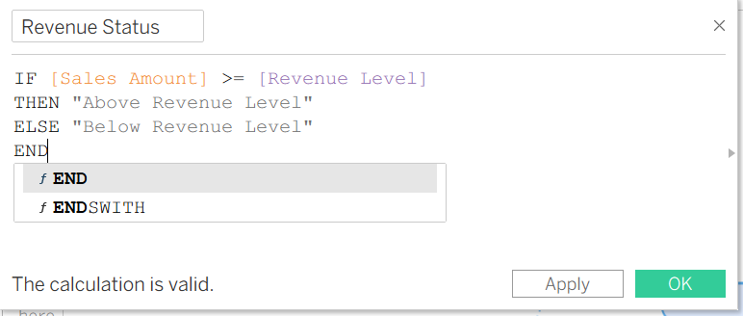

Step 6: Tableau Companion Dashboard & Interactive Story

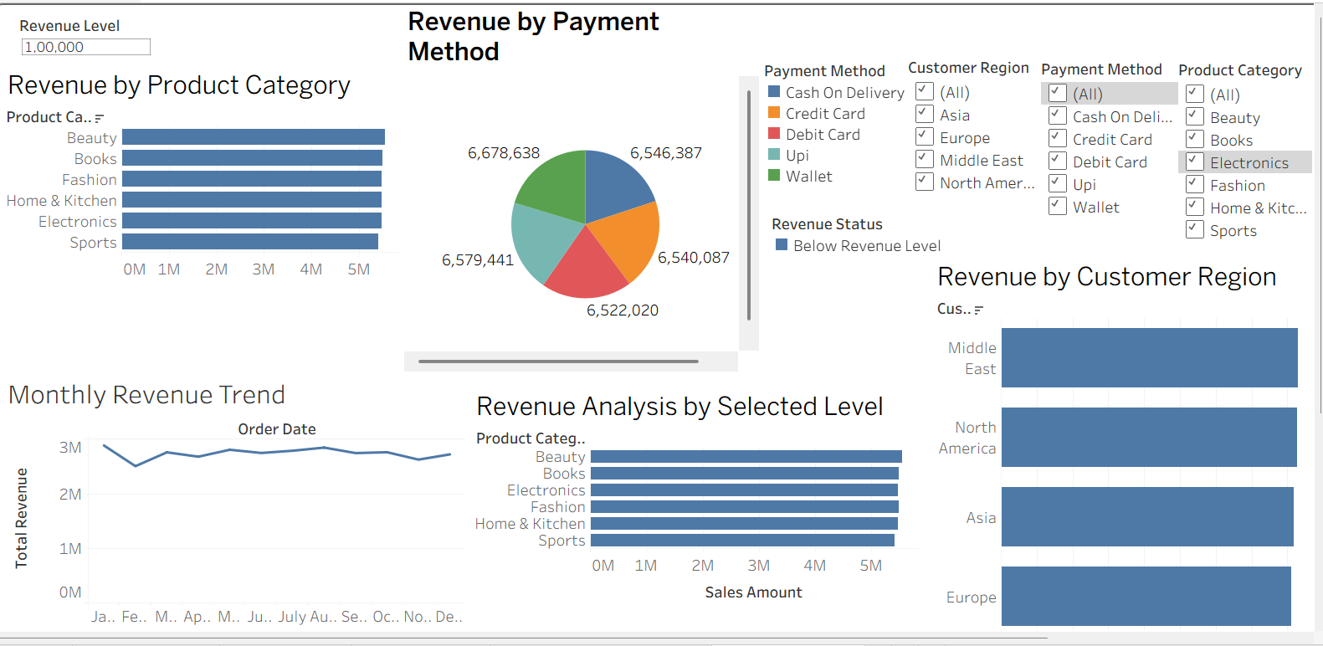
1. Worksheets:
Build the following worksheets in Tableau:
- Monthly Revenue Trend – Create a Line Chart to visualize revenue trends across months.
- Product Category Breakdown – Create a Bar Chart showing total revenue across different product categories.
- Customer Region Analysis – Create a Bar Chart to compare sales performance across customer regions.
- Payment Method Analysis – Create a visualization to analyze revenue or order distribution by payment method.
- Sales Distribution – Use appropriate charts to analyze pricing, discounts, quantity sold, and customer ratings.
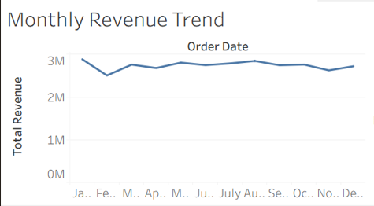

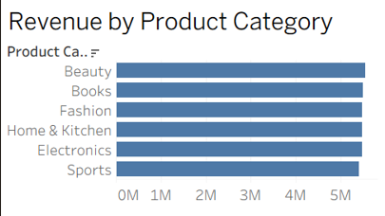

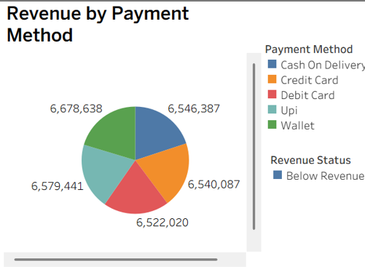

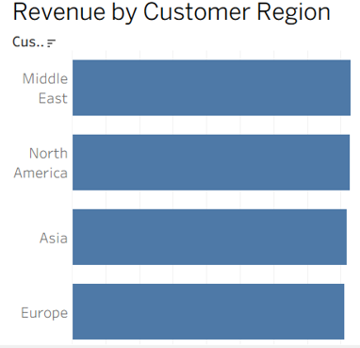
2.Revenue Analysis by Selected Level-Payment method, Customer Region, Product Category, Revenue Level, Revenue Status.
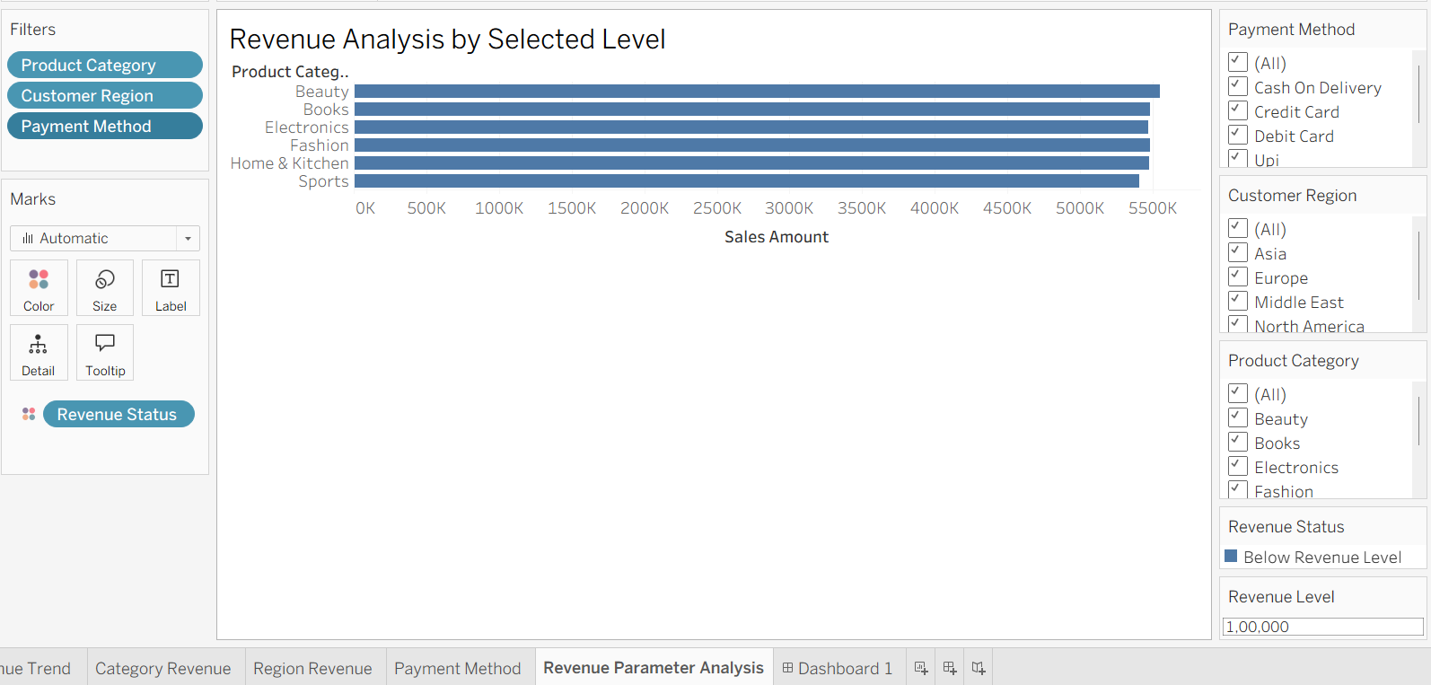

Observed Insights:
- Sales Performance: 50,000 Amazon sales orders were analyzed for 2022–2023.
- Revenue Trend: Monthly revenue varies across the period, highlighting high and low sales months.
- Product Categories: Revenue and quantity sold differ across product categories.
- Regional Sales: Customer regions show variations in order volume and revenue.
- Discount Analysis: Discounts influence the final selling price and overall sales.
- Customer Feedback: Ratings and review counts provide insights into customer satisfaction and engagement.
- Payment Methods: Sales activity varies across different payment methods

